EXPERIMENT 1
CODE:
<!DOCTYPE html>
<html lang="en">
<head>
<meta charset="UTF-8">
<meta name="description"content="A Samaple Webpage showing head tag usage">
<meta name="author"content="student Name">
<meta name="viewport" content="width=device-width, initial-scale=1.0">
<title>Sample Web Page</title>
<link rel="stylesheet" href="styles.css">
<style>
body {
font-family: Arial, sans-serif;
background-color: #f0f8ff;
}
</style>
<script>
console.log("Page Loaded Successfully!");
</script>
</head>
<body>
<header>
<h1>Welcome to My Web Page</h1>
</header>
<main>
<p>This page demonstrates the use of head section tags.</p>
</main>
<footer>
<p>&copy; 2025 Student Name. All rights reserved.</p>
</footer>
</body>
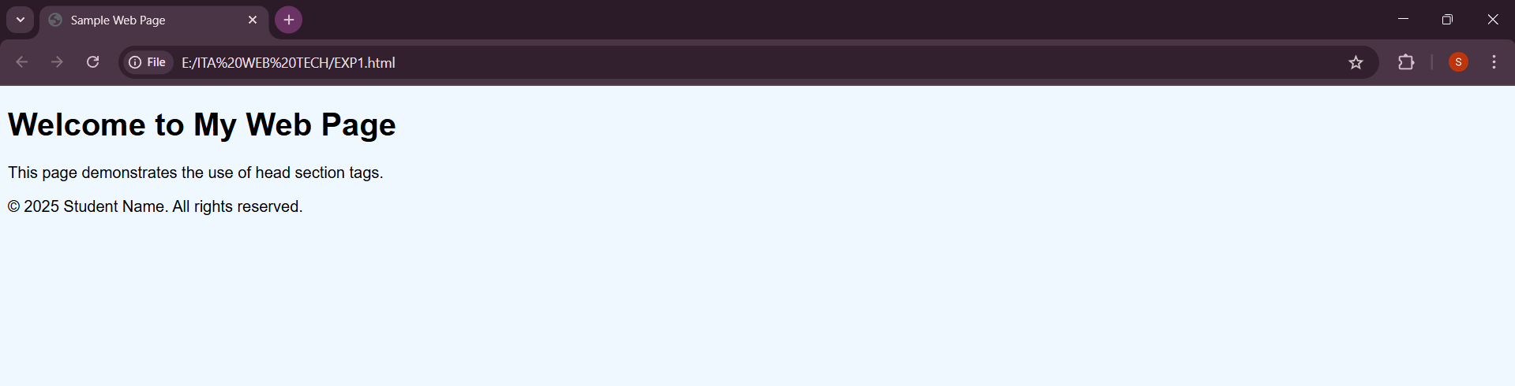
</html>
OUTPUT:

